

**Vashu Dev Malik**

# Document Version Control

|  |  |  |  |
| --- | --- | --- | --- |
| **Date Issued** | **Version** | **Description** | **Author** |

HIGH-LEVEL DESIGN

|  |  |  |  |
| --- | --- | --- | --- |
| 17/09/2022 | 1.0 | Abstract, Introduction, General Description | Vashu Dev Malik |
| 22/09/2022 | 1.1 | Design Detail, KPI, Deployment | Vashu Dev Malik |
| 10/10/2022 | 1.2 | Final Revision | Vashu Dev Malik |

**2**

# Contents

Document Version Control 2

Abstract 3

1. Introduction 4
   1. Why this High-Level Design Document? 4
   2. Scope… 4
2. General Description… 5
   1. Product Perspective & Problem Statement 5
   2. Tools Used 5
3. Design Detail 6
   1. Functional Architecture 6
   2. Optimization 7
4. KPI 8
   1. KPIs (Key Performance Indicators) 9
5. Deployment 9

**|** P a g e A N A L Y Z I N G A M A Z O N S A L E S D A T A

HIGH-LEVEL DESIGN

# ABSTRACT

Organizations under the E-commerce industry seek to attain core competence by creating and sustaining a unique process to collect personal information about customers and their purchasing trends. The report critically evaluates how a service-based organization Amazon uses Management information systems as a vibrant tool in attaining competitive advantage through efficient management and acquisition of information. As in today’s market without proper sales management, it’s very hard to predict how the business is running and how it will be in future. Many companies with proper sales management have shown better growth as they already know which item they have to focus on, which product needs some improvement etc. Sales Management helps in maintaining its customer base for a longer time by providing them attractive offers, as they already have the information’s like who are their top customers, whom they have to focus on etc. Sales Management also helps in minimizing the losses. Also, Competition is increasing day by day as many new companies are coming with better management systems and giving tough competition due to that it is now very important to have a proper Sales Management to run any business and to compete with these companies.

#### 3

**|** P a g e A N A L Y Z I N G A M A Z O N S A L E S D A T A

HIGH-LEVEL DESIGN

# Introduction

## Why this High-Level Design Document?

The purpose of this High-Level Design (HLD) document is to add the necessary detail to the current project description to represent a suitable model for coding. This document is also intended to help detect contradictions before coding and can be used as a reference manual for how the modules interact at a high level.

#### The HLD will:

* + - Present all of the design aspects and define them in detail
    - Describe the user interface being implemented
    - Describe the hardware and software interfaces
    - Describe the performance requirements
    - Include design features and the architecture of the project • List and describe the non-functional attributes like:

-Security

-Reliability

-Maintainability

-Portability

-Reusability

-Application compatibility

-Resource utilization

-Serviceability

## Scope

The HLD documentation presents the structure of the system, such as the database architecture, application architecture (layers), application flow (Navigation), and technology architecture. The HLD uses non-technical to mildly-technical terms which should be understandable to the administrators of the system.

# General Description

## Product Perspective & Problem Statement

**4 |** P a g e A N A L Y Z I N G A M A Z O N S A L E S D A T A

HIGH-LEVEL DESIGN

This Project aims to Analyze Amazon Sales from 2017 to 2019 to know more in-depth information about the items that are in high demand, items that are generating high profits which items should not be sold and how much stock we have to maintain for further Sales etc.

## Tools used

Business Intelligence tools and libraries works such as NumPy, Pandas, Seaborn, Matplotlib, MS-Excel, MS-Power BI, Jupyter Notebook and Python Programming Language are used to build the whole framework.



**5 |** P a g e A N A L Y Z I N G A M A Z O N S A L E S D A T A

HIGH-LEVEL DESIGN

# Design Details

## Functional Architecture

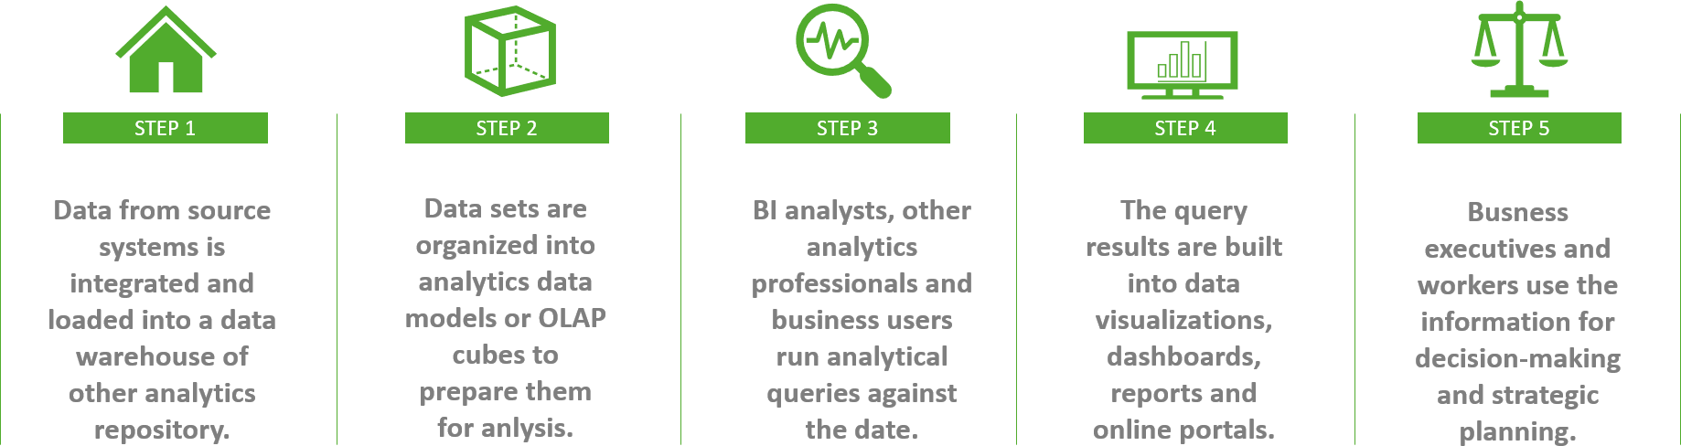

Figure 1: Functional Architecture of Business Intelligence

**How BI Works**

|  |  |  |  |  |
| --- | --- | --- | --- | --- |
| ORGANIZATIONAL MEMORY |  | INFORMATION INTEGRATION |  | INSIGHT CREATION |

PRESENTATION

**6 |** P a g e A N A L Y Z I N G A M A Z O N S A L E S D A T A

HIGH-LEVEL DESIGN



-Data Warehouse

-Enterprise resource planning (ERP)

-Knowledge Repository

-Content Management System (CMS)



-Business

Analytical Tools

-Data Mining

-Real Time

Decision



-Text Mining Tool

-Web Mining Tool

-Environmental Scanning

-RFID



-Online Analytical Processing (OLAP) Tool

-Visualization Tool

-Digital Dashboard

-Score Card

# Optimization

### Your data strategy drives performance

Minimize the number of fields Minimize the number of records Optimize extracts to speed up future queries by materializing calculations, removing columns and the use of accelerated views



### Reduce the marks (data points) in your view

* + Practice guided analytics. There’s no need to fit everything you plan to show in a single view. Compile related views and connect them with action filters to travel from overview to highly-granular views at the speed of thought.
  + Remove unneeded dimensions from the detail shelf.

 Explore. Try displaying your data in different types of views.

### Limit your filters by number and type

* + Reduce the number of filters in use. Excessive filters on a view will create a more complex query, which takes longer to return results. Double-check your filters and remove any that aren’t necessary.
  + Use an include filter. Exclude filters load the entire domain of a dimension while including filters do not. An include filter runs much faster than an exclude filter, especially for dimensions with many members.

**7 |** P a g e A N A L Y Z I N G A M A Z O N S A L E S D A T A

HIGH-LEVEL DESIGN

* Use a continuous date filter. Continuous date filters (relative and range-ofdate filters) can take advantage of the indexing properties in your database and are faster than discrete data filters.
* Use Boolean or numeric filters. Computers process integers and Booleans (t/f) much faster than strings.
* Use parameters and action filters. These reduce the query load (and work across data sources).

### Optimize and materialize your calculations

Perform calculations in the database Reduce the number of nested calculations.



* + Reduce the granularity of LOD or table calculations in the view. The more granular the calculation, the longer it takes.
    - LODs - Look at the number of unique dimension members in the calculation.
    - Table Calculations - the more marks in the view, the longer it will take to calculate.
  + Where possible, use MIN or MAX instead of AVG. AVG requires more processing than MIN or MAX. Often rows will be duplicated and display the same result with MIN, MAX, or AVG.
  + Make groups with calculations. Like include filters, calculated groups load only named members of the domain, whereas Tableau’s group function loads the entire domain.
  + Use Booleans or numeric calculations instead of string calculations. Computers can process integers and Booleans (t/f) much faster than strings. Boolean>Int>Float>Date>DateTime>String.

# KPI

Dashboards will be implemented to display and indicate certain KPIs and relevant indicators for the disease.



**8 |** P a g e A N A L Y Z I N G A M A Z O N S A L E S D A T A

HIGH-LEVEL DESIGN

As and when the system starts to capture the historical/periodic data for a user, the dashboards will be included to display charts over time with progress on various indicators or factors

# KPIs (Key Performance Indicators)

Key indicators displaying a summary of Sales Data and its relationships with different metrics.

1. Yearly, Quarterly, Monthly Ups and Downs in Sales & Profits.
2. Items That Generated Highest Sales, Profit etc.
3. Top 5 Items that generated highest Sales and Top 5 Items by Quantity.
4. Bottom 5 Items that generated Lowest Sales and Bottom 5 Items by Quantity.
5. Forecasting.

# Deployment

Prioritizing data and analytics couldn’t come at a better time. Your company, no matter what size, is already collecting data and most likely Analysing just a portion of it to solve business problems, gain competitive advantages, and drive enterprise transformation. With the explosive growth of enterprise data, database technologies, and the high demand for analytical skills, today’s most effective IT organizations have shifted their focus to enabling self-service by deploying and operating Power BI at scale, as well as organizing, orchestrating, and unifying disparate sources of data for business users and experts alike to author and consume content.

Power BI prioritizes choice in flexibility to fit, rather than dictate, your enterprise architecture. Power BI Desktop and Power BI Service leverage your existing technology investments and integrate them into your IT infrastructure to provide a self-service, modern analytics platform for your users. With on-premises, cloud, and hosted options, there is a version of Power BI to match your requirements.

**9 |** P a g e A N A L Y Z I N G A M A Z O N S A L E S D A T A

HIGH-LEVEL DESIGN

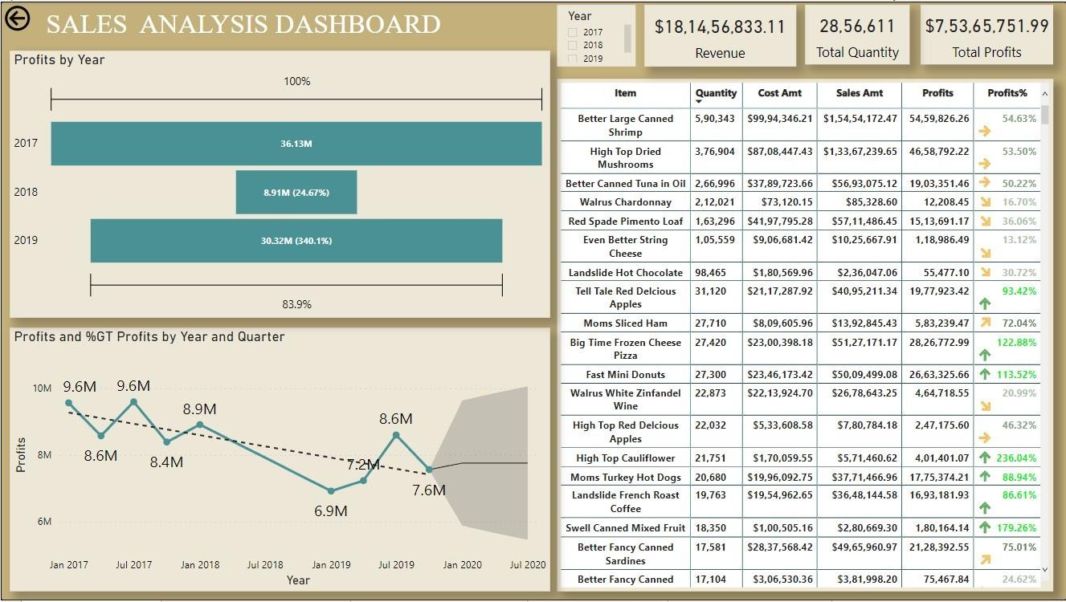

**10 |** P a g e A N A L Y Z I N G A M A Z O N S A L E S D A T A

HIGH-LEVEL DESIGN

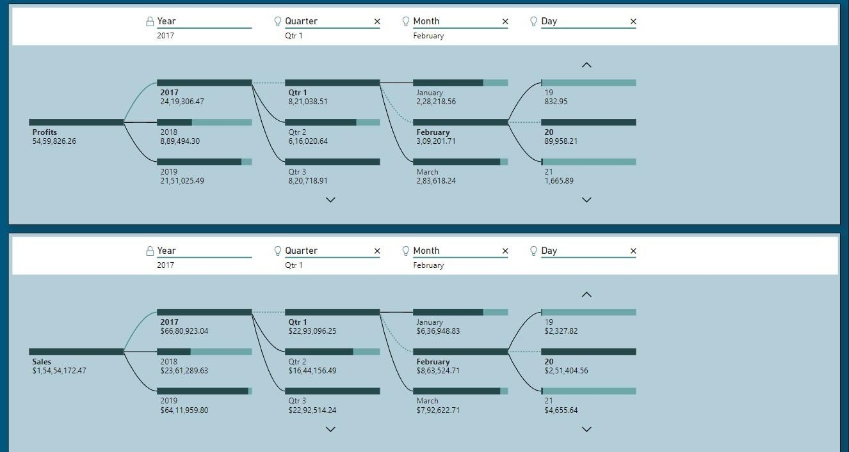

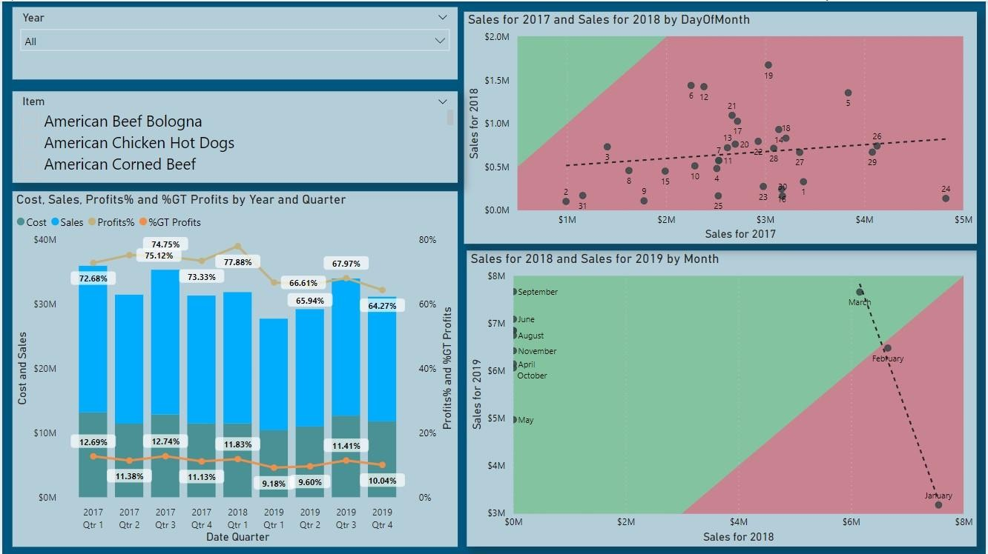

##### **11** A N A L Y Z I N G A M A Z O N S A L E S D A T A

HIGH-LEVEL DESIGN

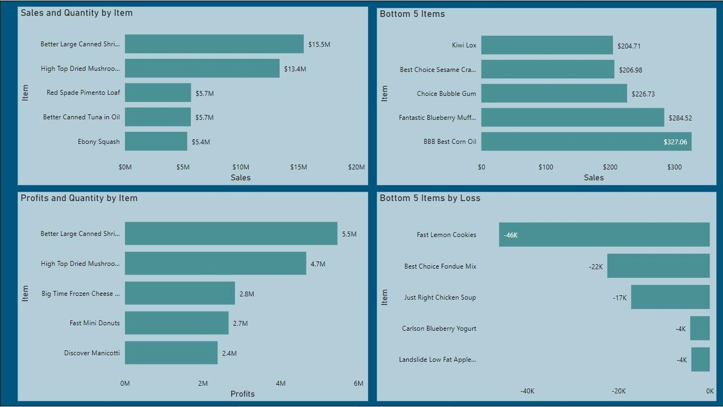**|** P a g e

##### **12** A N A L Y Z I N G A M A Z O N S A L E S D A T A

HIGH-LEVEL DESIGN

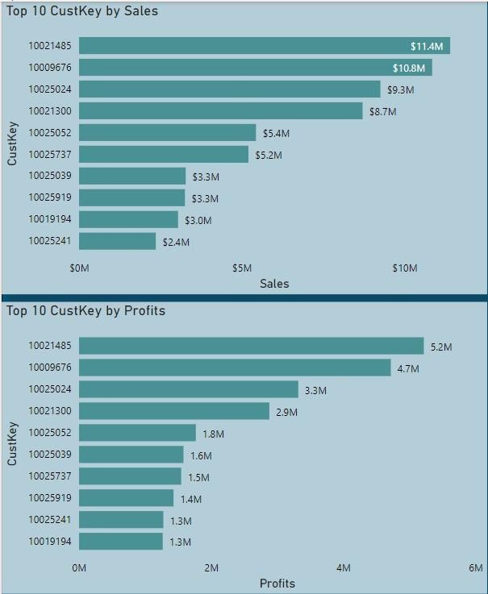

**|** P a g e

**13** A N A L Y Z I N G A M A Z O N S A L E S D A T A